Visit to Blottereau Park Greenhouses by Nia Came

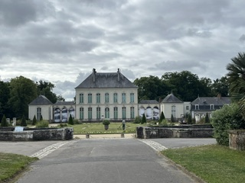

On Wednesday 10TH June we visited the greenhouses at Grand Blottereau Park in Nantes and were given a one and half hour guided tour with very knowledgeable park gardeners. Due to numbers, two groups were organised, the first one in French only and the second in French/English. I chose the second group.

The greenhouses were created in 1903 by the Colonial Agronomy section of the Higer School of Commerce, to prepare future colonists for colonial life and foster local trade. The goal was to learn about and cultivate the exotic plants found in the colonised countries.

The greenhouses (500m square) contain around 800 plants, and each year the plants are repotted. Some of the plants are 120 years old. Examples of the plants we saw are given below:

Sugar cane – first plant grown by slaves. Originally from Papua New Guinea but the main producer is now Brazil. Once extracted from the cane, the juice is heated up, then crystallizes into sugar.

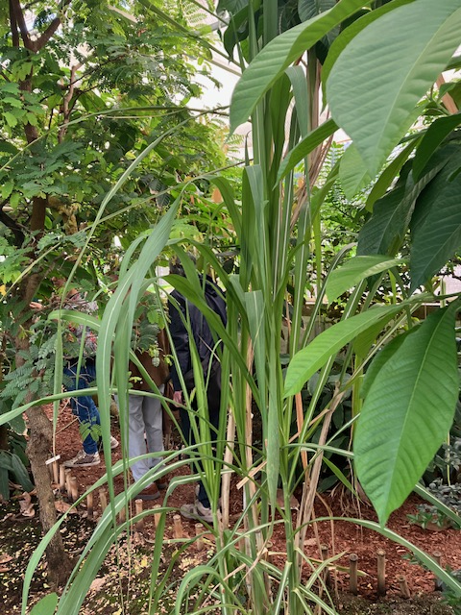

Coffee – Ethiopian. The fruit is the coffee cherry. Coffee is produced by separating the seeds from the pulp, drying and roasting, which releases the aroma.
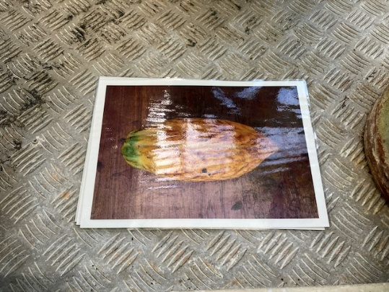
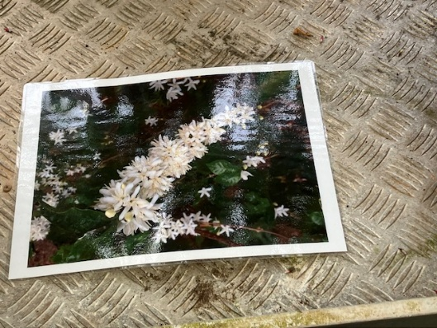
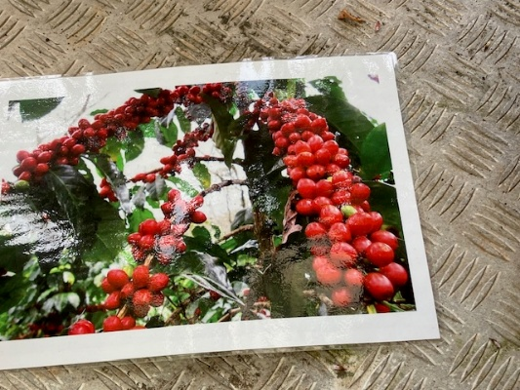

Chocolate- the fruit is the cocoa pod and the seeds are the cocoa beans. They are also dried and roasted.

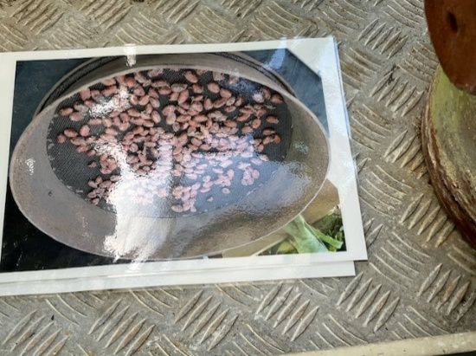
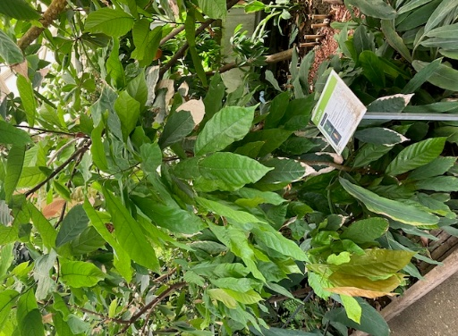

Vanilla – originally from Mexico but the world’s largest producer is currently Madagascar. The fruit is the pod and it is pollinated by hand so very labour intensive and consequently prices for vanilla remain high.

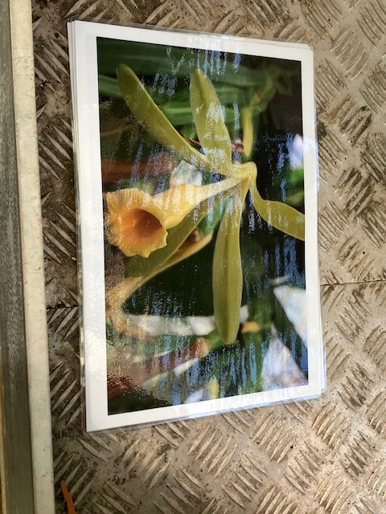

Cinnamon – Sri-Lankan. The bark, once harvested, curls up and forms the cinnamon sticks.

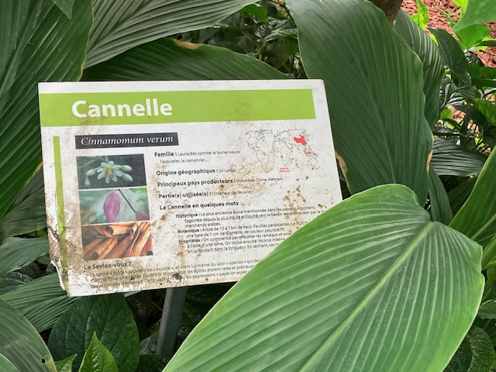
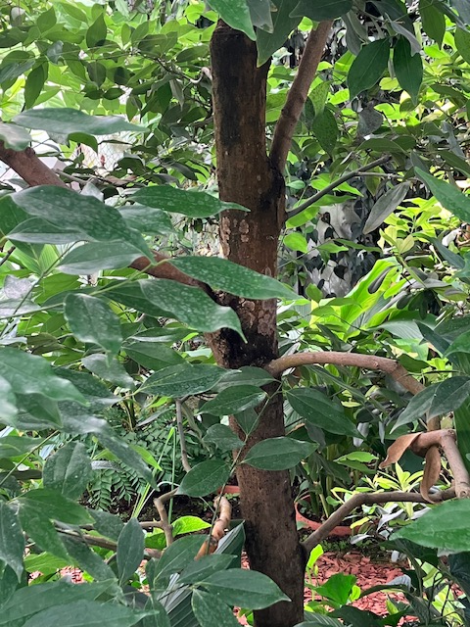

Tamarind – African. The Tamarind tree is famous for its sweet and sour edible pods.The tangy sticky pulp is used widely in both Asian and South American cooking to produce flavoursome savoury sauces. The tree is highly durable and used in carpentry.

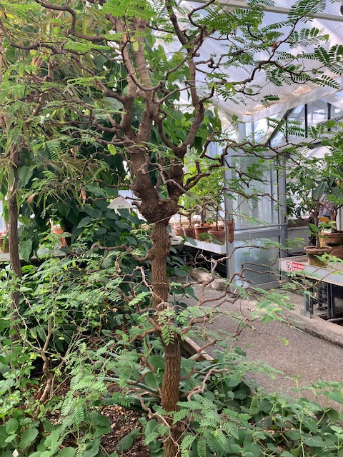

Baobab – African. The flower is pollinated by bats at night. The fruit is the monkey-bread. The plant can hold enormous reserves of water so elephants and other animals such as antelopes chew the bark during the dry season.

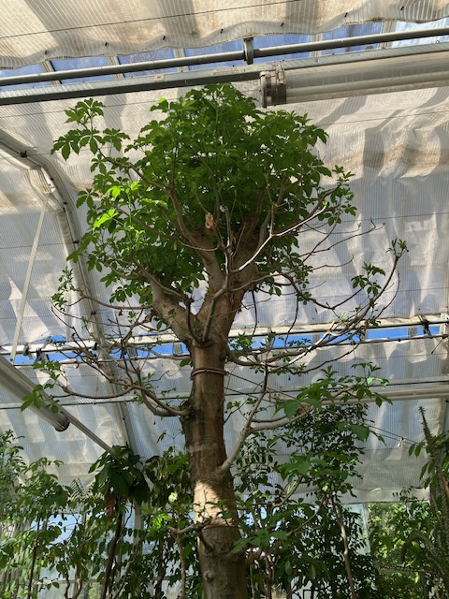

Ebony – very dense and precious wood. Used for cutlery, musical instrument fret boards, piano keys and fine cabinetry

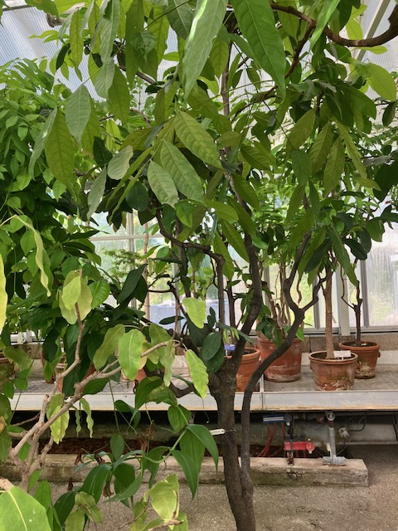

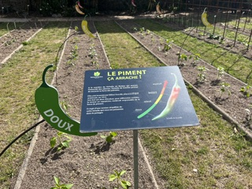
Close to the greenhouses are the Tropical Gardens and below are three photos.

