Visit to Le Lac de Grand Lieu by Carol O’Byrne

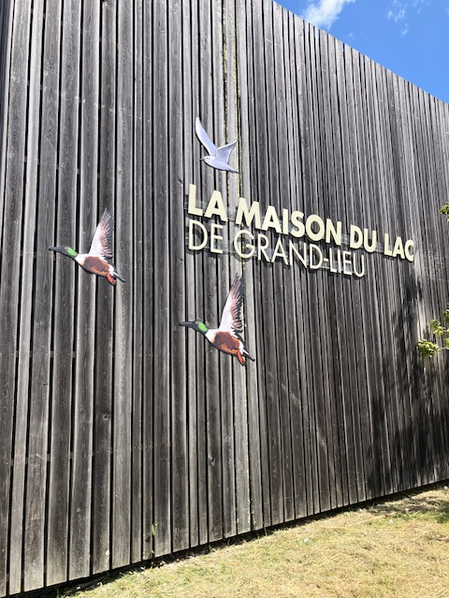

We had the immense good luck to spend the Wednesday afternoon of the Exchange at La maison du Lac de Grand Lieu in beautiful sunshine.

This lake, which is at about 18 km from Nantes, is at the centre of a very special nature reserve. Today the 26,946 sq km site has the designation Reserve Naturelle de France with the highest level of protection because of its rare and special characteristics.

It is the second largest such reserve in France, the reserve in the Camargue being the biggest. There are a huge number of species of flora and fauna :– 270 different types of birds, 50 species of mammals, 30 species of fish and 12 different types of amphibians. This makes the Lake and its surrounding area a vital habitat for so many creatures and plants.

The lake is in a basin (une cuvette) formed by the tectonic plates of the Great European Plain. Being approximately 25km from the Atlantic Ocean as well as low lying on an estuary gives the area a humid and marshy habitat. There are annual floods which contribute to the environment and during the winter the lake usually doubles in size.

We formed two groups at the lake and had as guides Matthieu and Morgan. They both had their particular ways of presenting the information and both gave us a wonderful introduction to the area.

Matthieu led our group and we walked from the Visitors' Centre down to the lake side. We immediately had a sense of the scale of the reserve as we walked along the various meadows and trees. There was a tremendous feeling of peacefulness as we walked along through the fields, hearing the birdsong and the chirping of the grasshoppers.

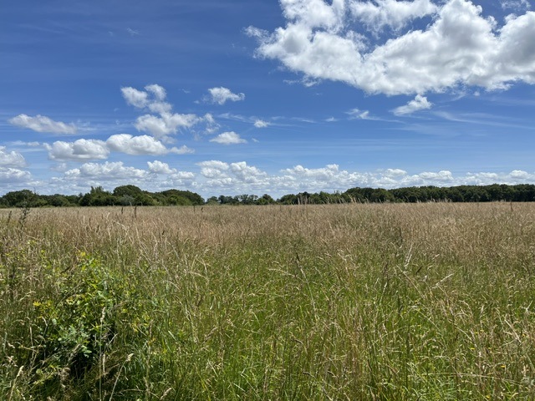
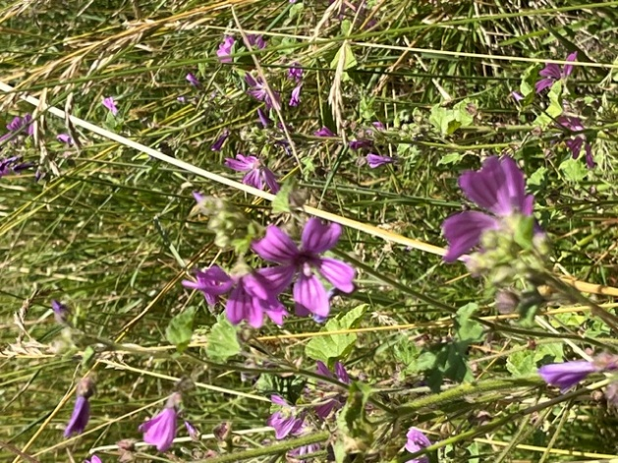

As well as the nature and geography of the reserve, our guide explained its history. From the 1950's the land belonged to Jean-Paul Guerlain the perfumier. Guerlain came here to fish and hunt and built a holiday home. As he and his wife had no children, they left the house and all the land to the French State with the stipulation that it be made into a nature reserve.

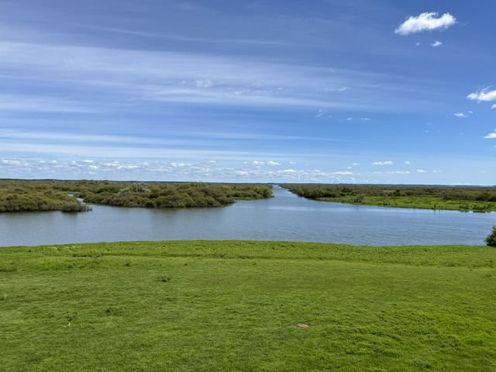

Many of the exchange participants said that the Lac de Grand Lieu was their favourite visit of the week and it is easy to see why!

