Visit to the Motor Museum at Louheac in Britany in June 2026 by Jane Corbett

The museum based in a 17th century manor house has been open to the public since 1988. It is owned by Michel Hommell, a passionate car collector who started when aged 18. He was previously a celebrated motorsport publisher, a racing driver and sports car manufacturer.
The museum has been expanded several times to accommodate more than 400 gleaming vehicles many life sized and others in miniature.
There is an impressive collection of car marques from the 1900’s onwards from a variety of countries. There are also some motorbikes, scooters, amphibious vehicles, army vehicles and over 30 horse drawn carriages. Classic powerboats are suspended from ceilings.

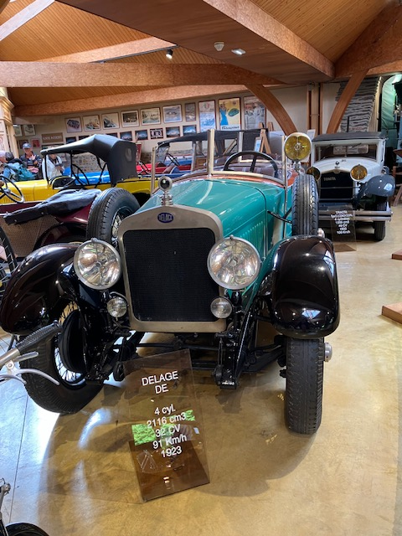
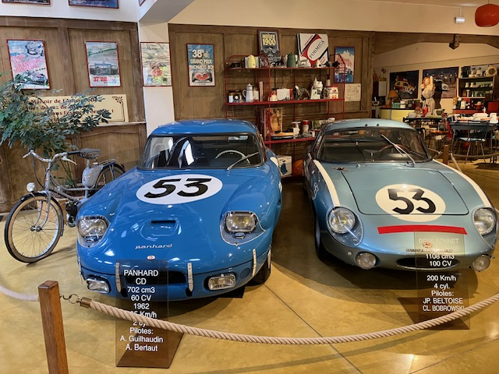

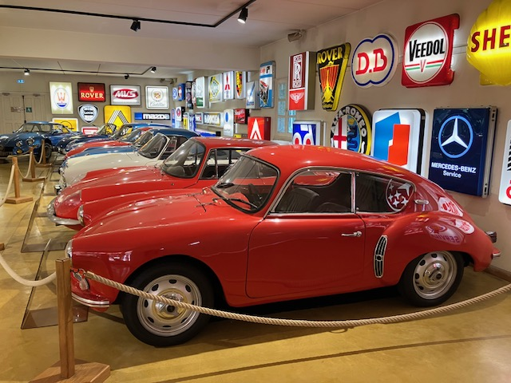
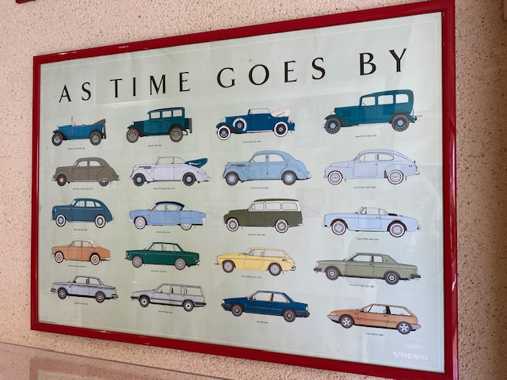
In one room there are 18 Formula 1 racing cars lined up as if on a starting grid . On the surrounding walls are displays featuring photographs of famous drivers such as James Hunt with their racing suits and other racing related objects.
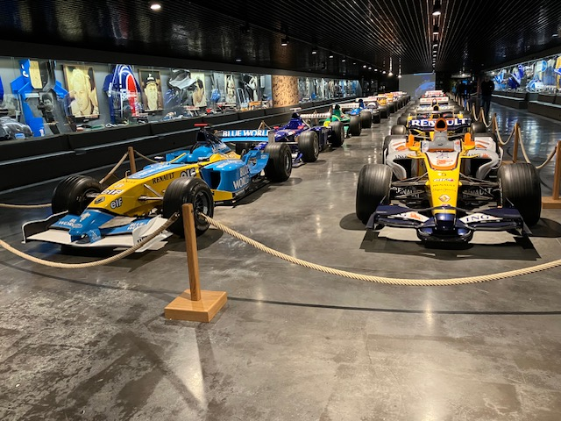

The museum on its upper floor also features scenes of life from the 1960’s with traditional trades and appropriate objects displayed.
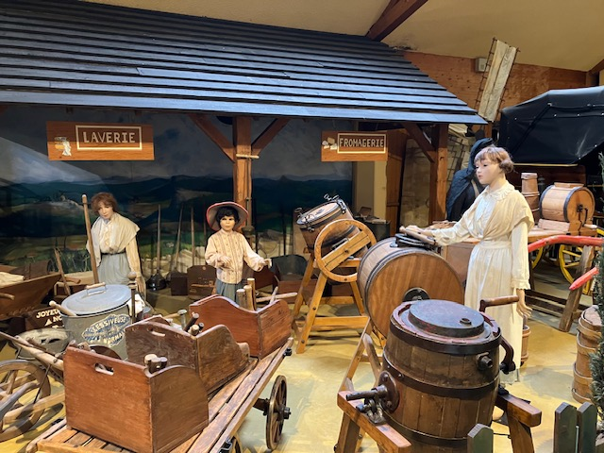

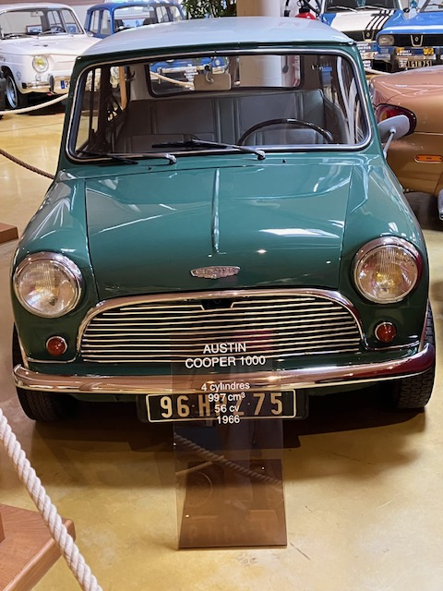
The visit was very interesting and absorbing even for those like me who are not car enthusiasts. However, I particularly enjoyed seeing the cars from my childhood which had lots of individuality and style.
