Visit to Musée Dobrée by Breched Piette

Our Thursday afternoon visit was to the Musée Dobrée near to the centre of Nantes. The museum had reopened some two years earlier after extensive renovation of a very interesting and attractive site and is comprised of a range of buildings from the medieval to the contemporary.

The collections were initially made in the nineteenth century by Thomas Dobrée, whose family fortune came from the slave trade and ship building.
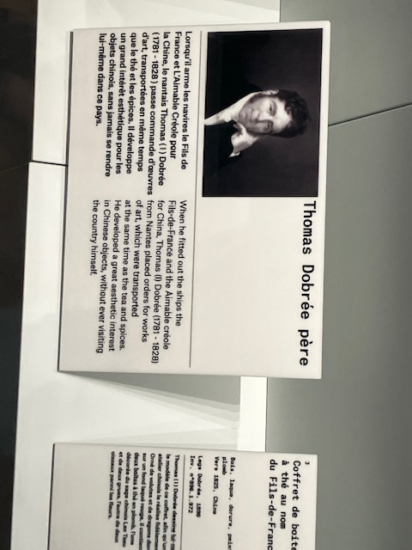

They were further developed by his son, also named Thomas, following his travels, mainly in China.

Over the next hundred years several other collectors added objects to the collections, including many items from Egypt, and the collections were also supplemented by items from the museum of archaeology.

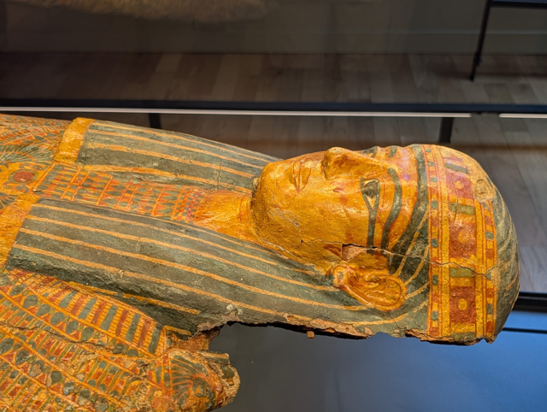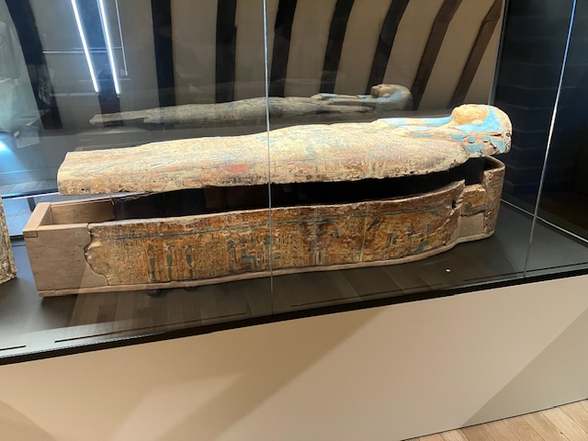

Other parts of the collection include art deco and art nouveau items and the famous Louis Majorelle vase made of glass with metal inclusions in a wrought iron frame.
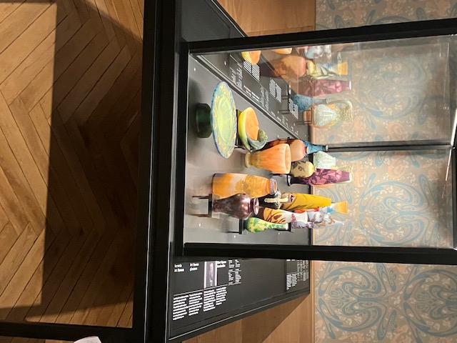
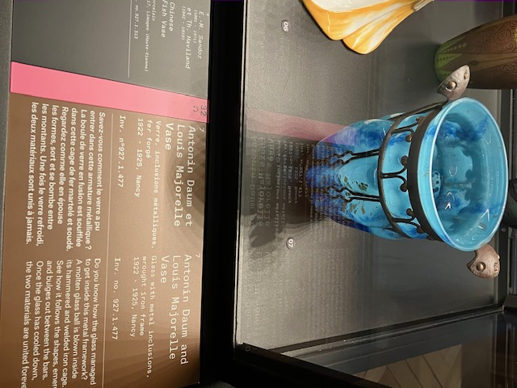

The very eclectic nature of the collection could have been somewhat confusing, but the guides who took us around focused in depth on five objects and their provenance - a helpful approach.

One of the oldest and most precious objects was a bronze age neck-ring made from gold, silver and copper dating from approximately 1500 BC. It was incredible to see such a beautiful and finely crafted object of this age.
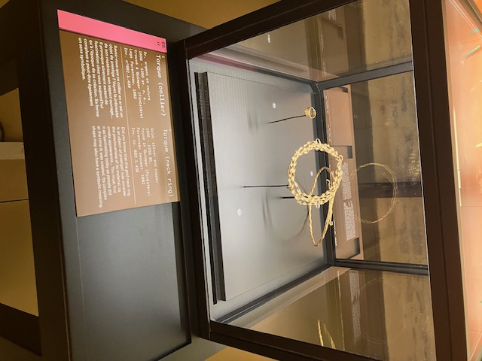

Another very fine piece of work was the gold funerary vessel containing the heart of queen Anne of Britanny dating from 1514: although the heart had turned to dust the funerary vessel in which her heart had been placed was a reminder of her historic importance in Brittany.
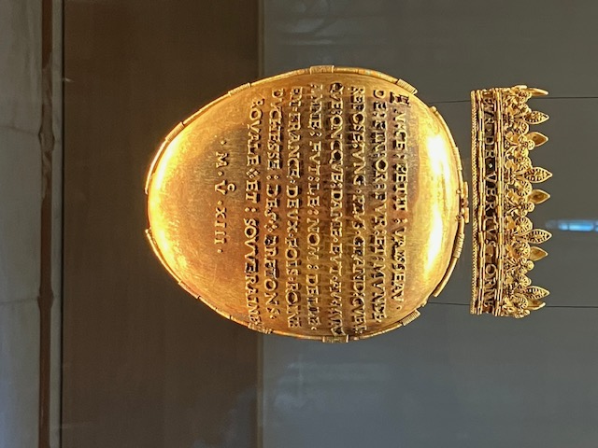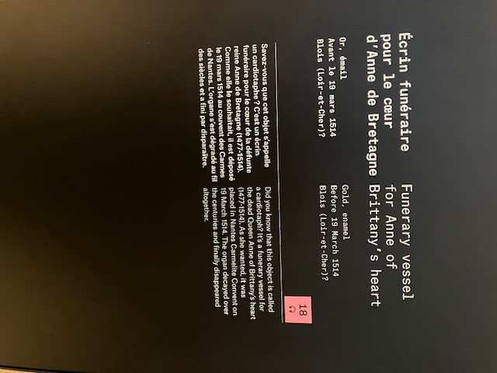

Other objects we were shown were containers of mummified objects from Ancient Egypt, Art nouveau and art deco vases from the early twentieth century and a beautiful red lacquered box for transporting tea from China.

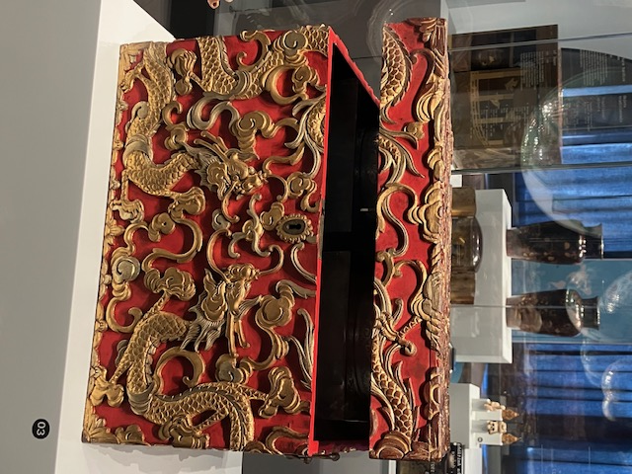

Overall, some amazing objects demonstrating the riches of Nantes and the connections of the city with many parts of the world.

We were also pleased that ample seating was available throughout the galleries!

