Visit to Pornic Chateau by Siobhan Dakin

We visited the pretty tourist coastal town of Pornic about an hour’s coach journey west of Nantes to mainly visit the chateau but also to have the opportunity to explore the town and if you wished to also visit the heraldic shield workshop.
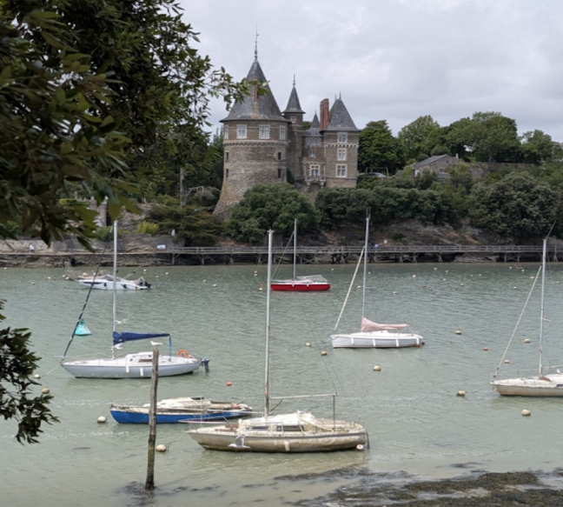

Roberte Voguee and his wife the owners of the Chateau conducted the tour in French and Francoise Hautcoeur (from ELANC our Nantes exchange partner) translated this into English.
The Chateau has been in the family for four generations but its origins date back to a wooden structure built in the 10th century. It has a wonderful vantage point which was previously used to observe enemies such as the Vikings in the 12th century, or traders arriving by sea into the harbour, which is well protected from the Atlantic.

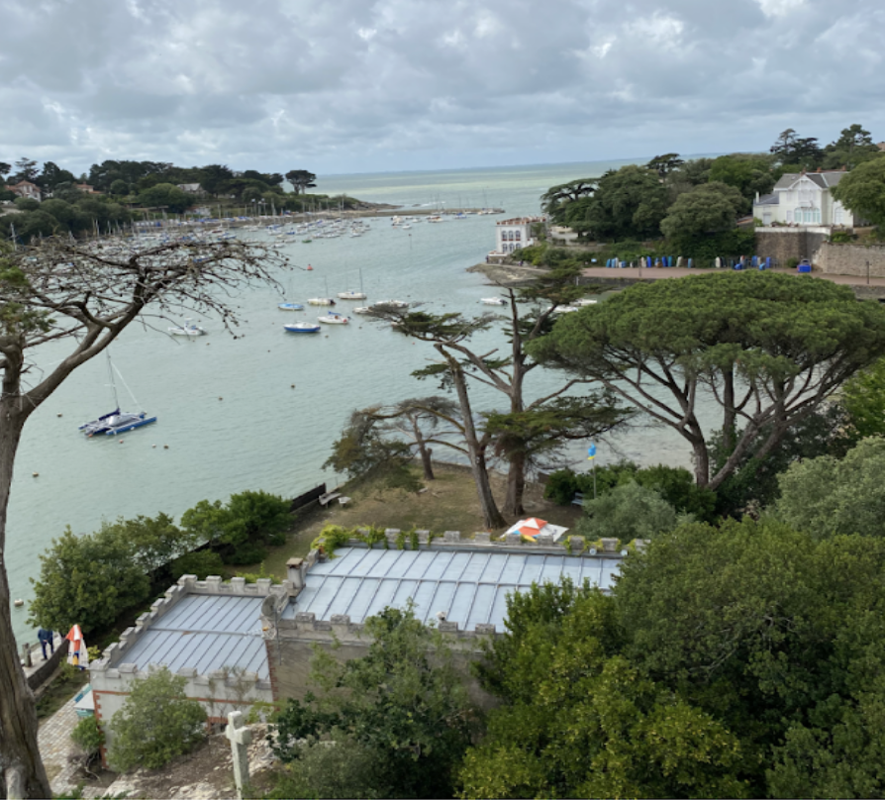

We learned that Giles de Rais, military chief to Jeanne d’Arc owned the chateau for a period in the 13th century. The Chateau was abandoned after the French Revolution.
In 1792 Monsieur Lebreton bought the chateau and created a heated bath house for tourists, having been impressed by those he saw operating in England. He also constructed the first hotel nearby for increasing tourist numbers.
Pornic’s expansion as a resort led to the arrival of the railway in 1853 and it became a fashionable place. The writers Gustave Flaubert and Robert Browning were frequent visitors.

The Chateau has been altered and expanded many times. A second tower was added in 1899 and the current owner’s grandmother had a library and a chimney breast installed replicating the style of Chinon’s chateau. Several heraldic shields (blazon in French) were displayed on the chimney breast.

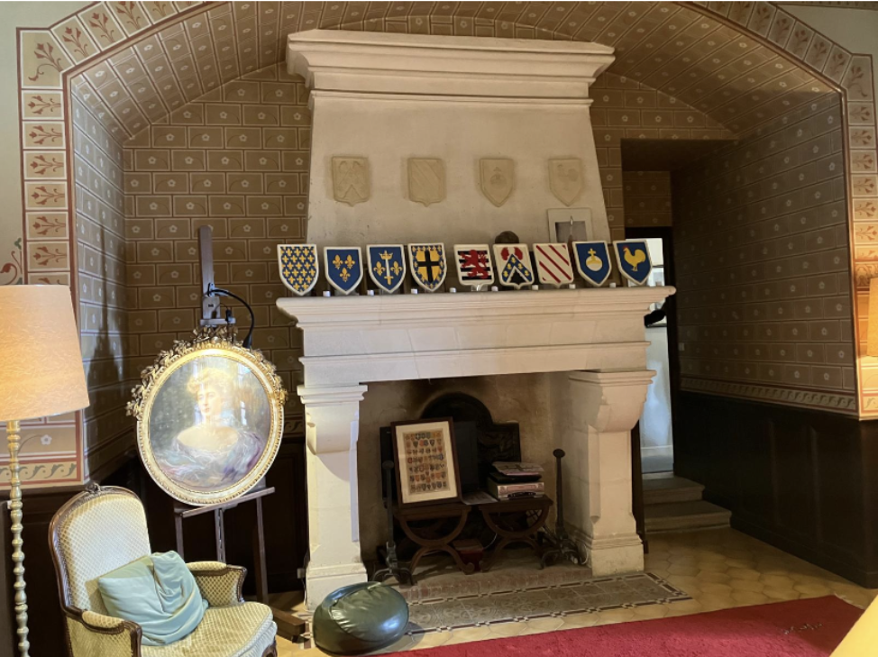

Our guide was very passionate about his family’s chateau, its history and explaining the different levels of heritage (patrimonie in French) and the associated funding aspects. I found it to be a delightful and informative tour of a charming chateau.

